**REPORT**

**Team member’s information:**

|  |  |  |
| --- | --- | --- |
| Name | Roll Number | Registration Number |
| Vedant Tilwani | 65 | 170905542 |
| Rahul Jain | 66 | 170905546 |

**Modifications in original ER diagram/schema:**

1) Made product-purchases-customer many to many.

2) Made product-supplies-supplier many to many.

3) Added salary to Employee.

5) Added instore table and name, address to customer & supplier tables.

**Creating tables:**

create table employee(ssn varchar(10)primary key, dob date,

designation varchar(10), store_id varchar(10), fname varchar(10),

lname varchar(10), salary number);

create table store(store_id varchar(10)primary key, phone

number, street varchar(10), city varchar(10), state varchar(10),

zip varchar (6), mng_id varchar(10));

create table product(product_id varchar(10)primary key,product_name

varchar(20), sprice number, cprice number);

create table customer(customer_id varchar(10)primary key, first_name

varchar(10), last_name varchar(10), phone_no number, flatno

varchar(5), building varchar(8), city varchar(10));

create table purchases(customer_id varchar(10), product_id varchar(10),

quantity number, from_store varchar (10), purchased_on date, primary key(customer_id,product_id,from_store));

create table supplies(supplier_id varchar(10), product_id varchar(10),

stock number, to_store varchar(10), supplied_on date, primary key(supplier_id,product_id,to_store));

create table supplier(supplier_id varchar(10)primary key,

sup_fname varchar(10),sup_lname varchar(10), shop_no varchar(3),

street varchar(10), city varchar(10), state varchar(10));

create table instore(store_id varchar(10), product_id varchar(10),

availability number, primary key(store_id,product_id));

alter table employee add foreign key(store_id) references store on delete cascade;

alter table store add foreign key(mng_id) references employee on delete cascade;

alter table purchases add foreign key(customer_id) references customer on delete cascade;

alter table purchases add foreign key(product_id) references product on delete cascade;

alter table purchases add foreign key(from_store) references store on delete cascade;

alter table supplies add foreign key(supplier_id) references supplier on delete cascade;

alter table supplies add foreign key(product_id) references product on delete cascade;

alter table supplies add foreign key(to_store) references store on delete cascade;

alter table instore add foreign key(store_id) references store on delete cascade;

alter table instore add foreign key(product_id) references product on delete cascade;

**LIST OF QUERIES:**

* select * from instore where product_id='pid';
* insert into employee values('ssn',to_date('dob','dd/mm/yyyy'),'de','sid','fn','ln',sall);
* delete from employee where ssn='s’;
* update employee set designation='desans' where ssn='empid';
* select * from instore where product_id='pid' and store_id='storeid';
* select sum(purchases.quantity*sprice) as sold from purchases,product where purchases.product_id=product.product_id
* select sum(supplies.stock*cprice) as cost from supplies,product where supplies.product_id=product.product_id;
* create or replace trigger del_emp

before delete on employee

for each row

begin

insert into ex_employee values(:old.ssn,

:old.dob,

:old.designation,

:old.store_id,

:old.fname,

:old.lname,

:old.salary);

end;

/

**UI DESIGN**

**View basic information**: Tells us how basic information can be viewed.

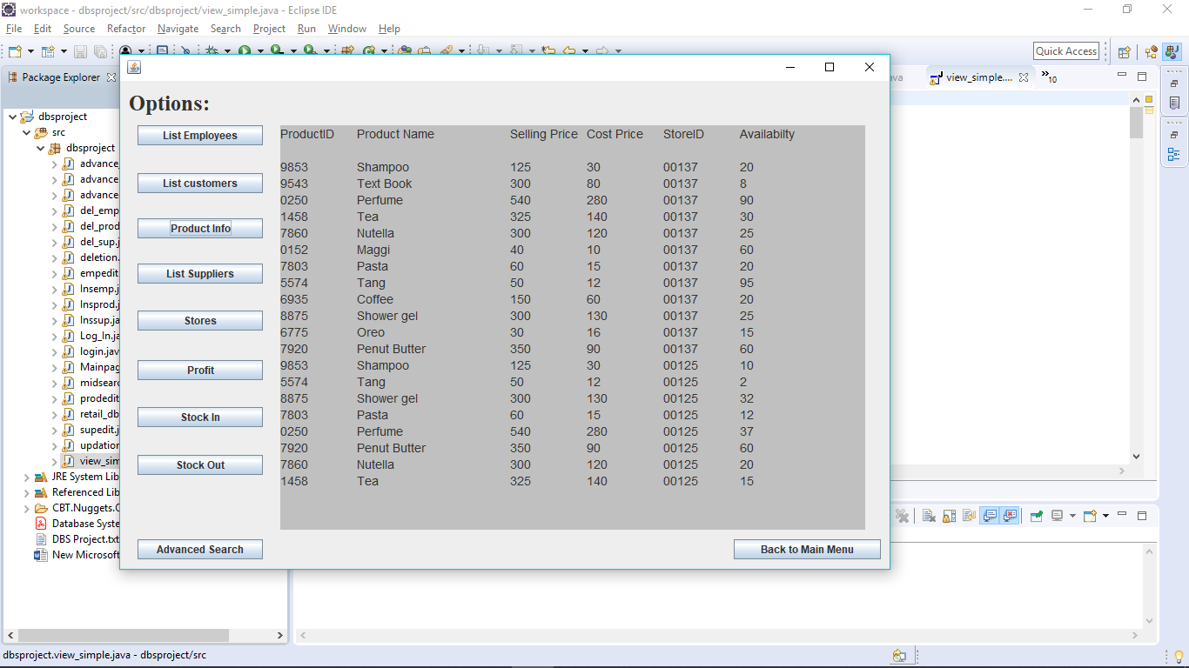

**View complex information** of Employees, Customers, Suppliers: Tells us how complex information is being viewed after multiple search criterias.

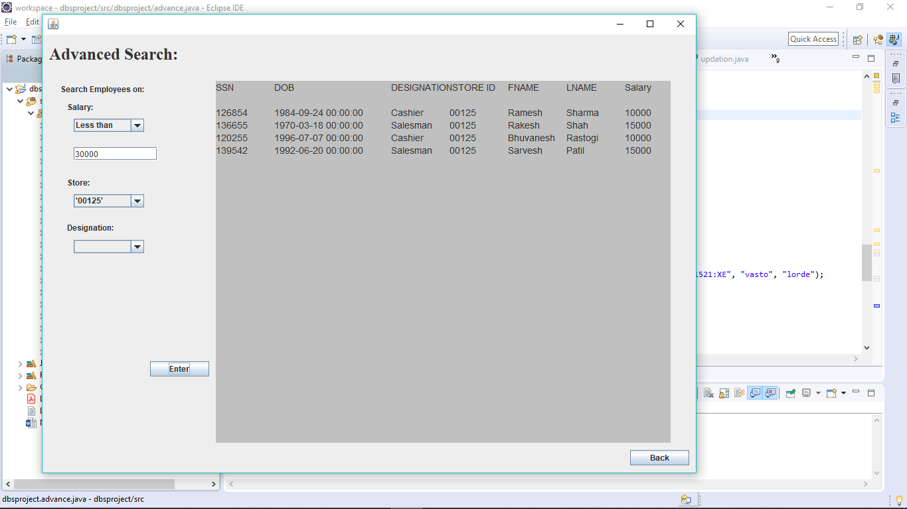

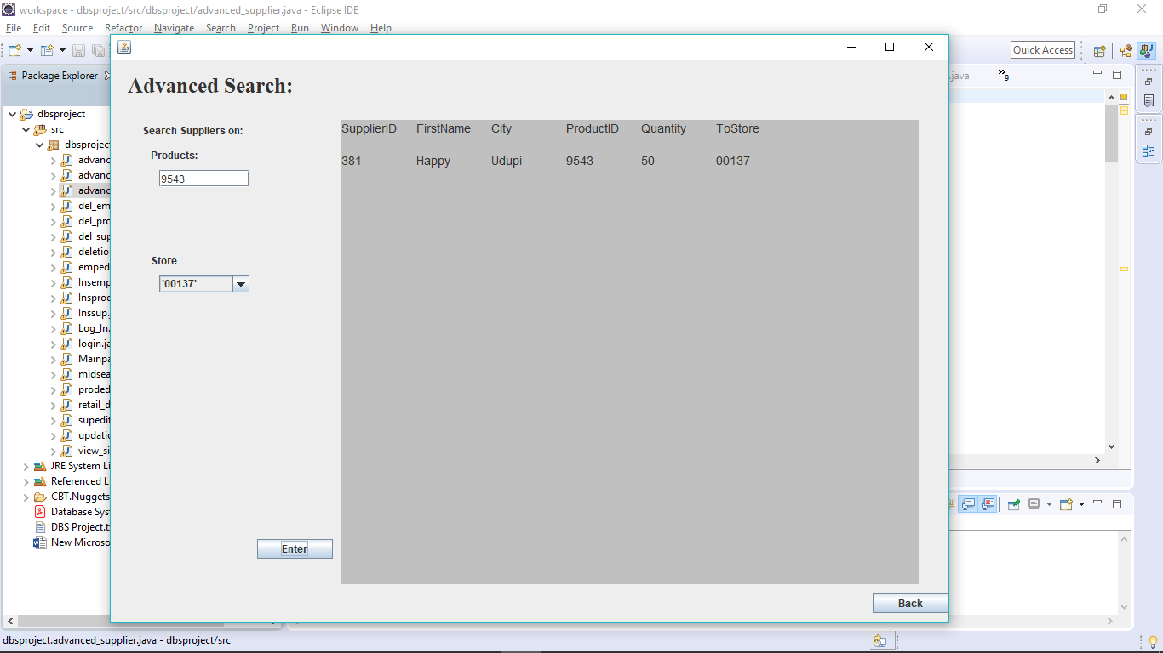zz

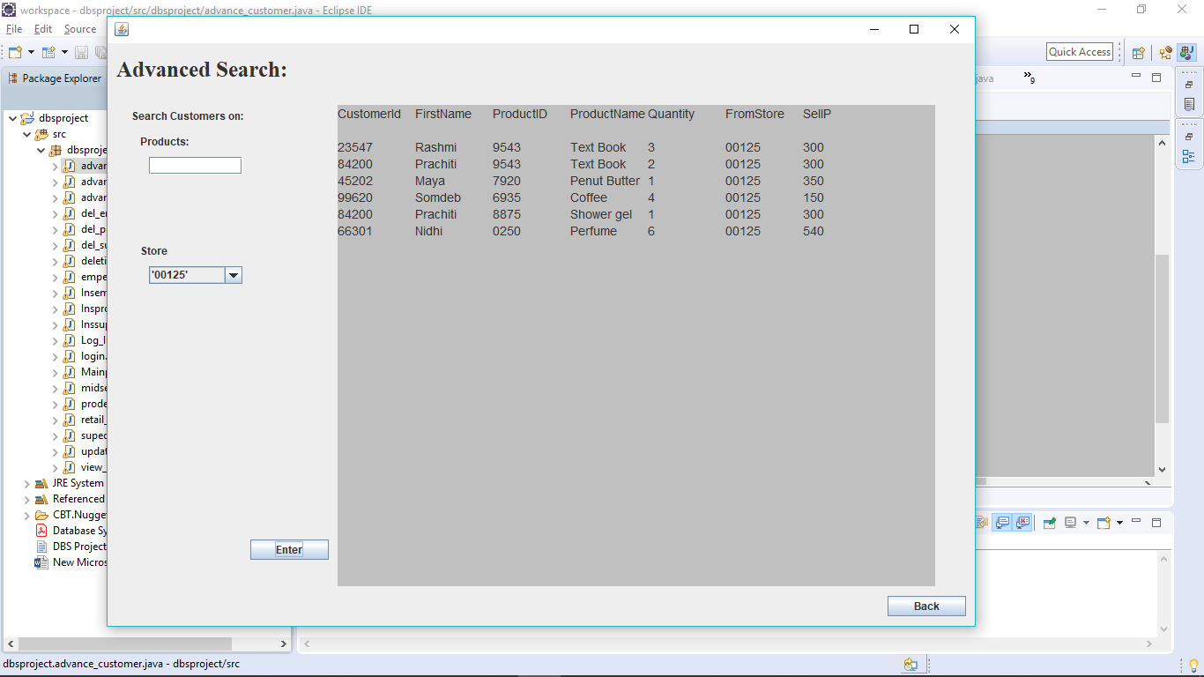

**Insert** Employee, Supplier, Product as: Tells us how we can insert values into the database

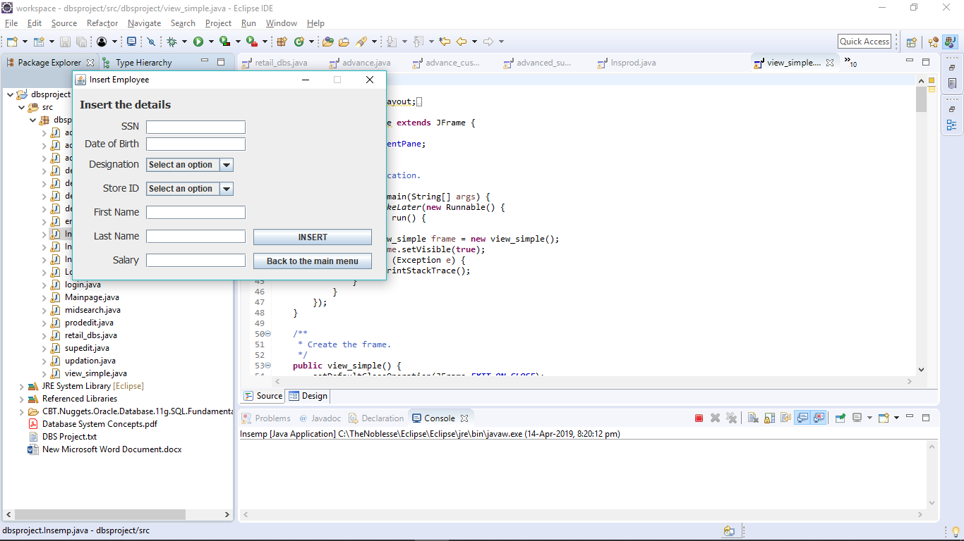

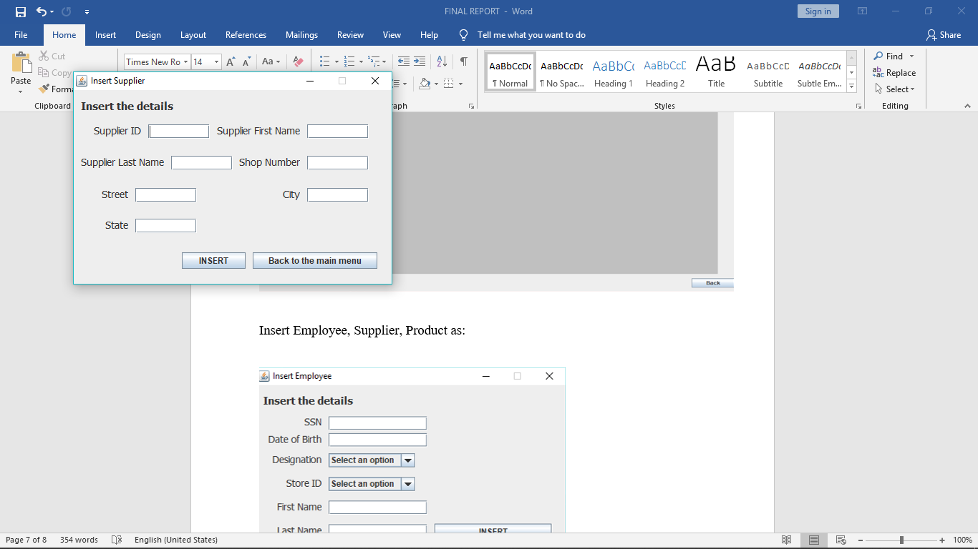

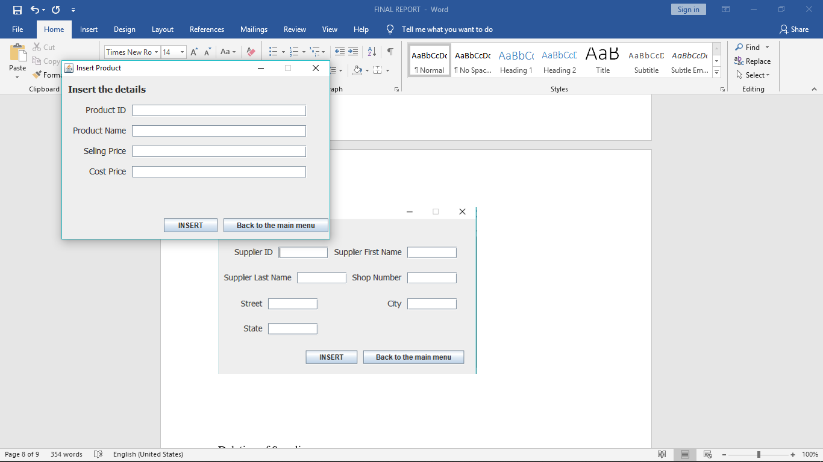

**Deletion** of Supplier, Employee, Product as: Tells us how we can delete values from the database

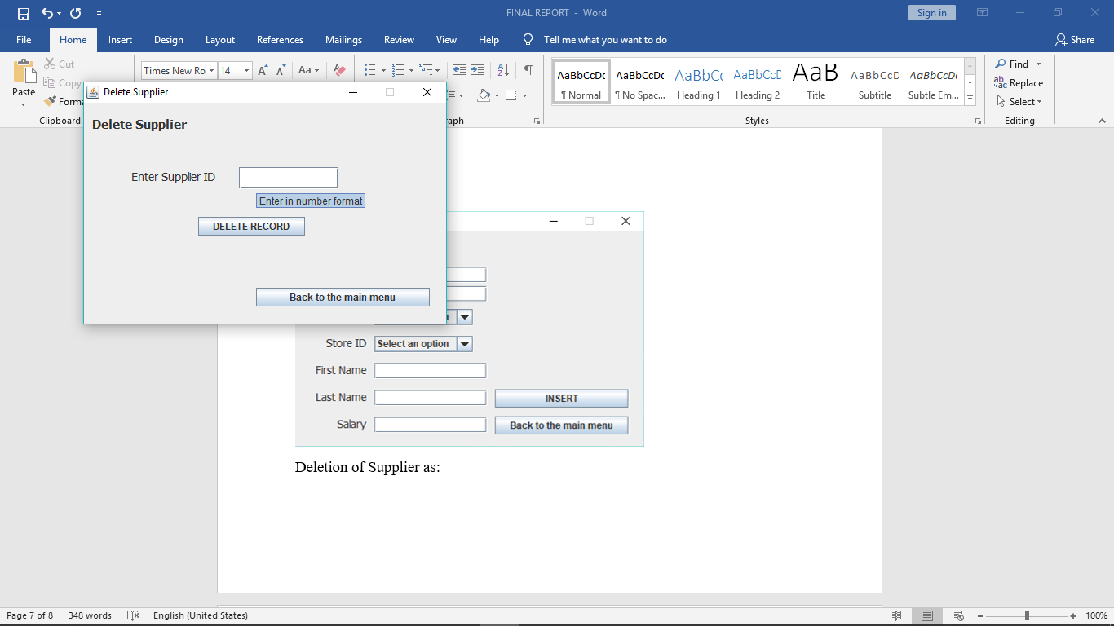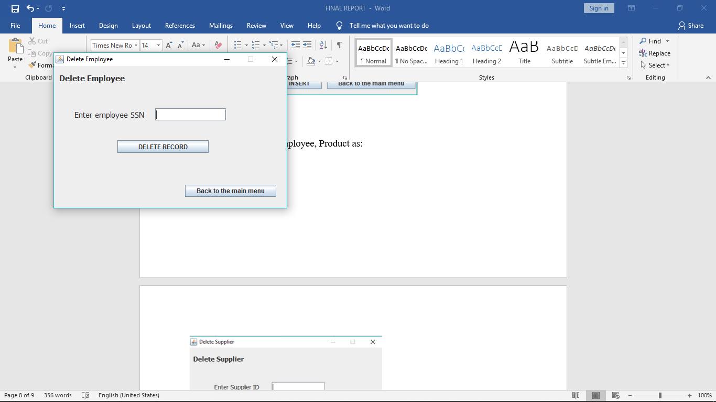

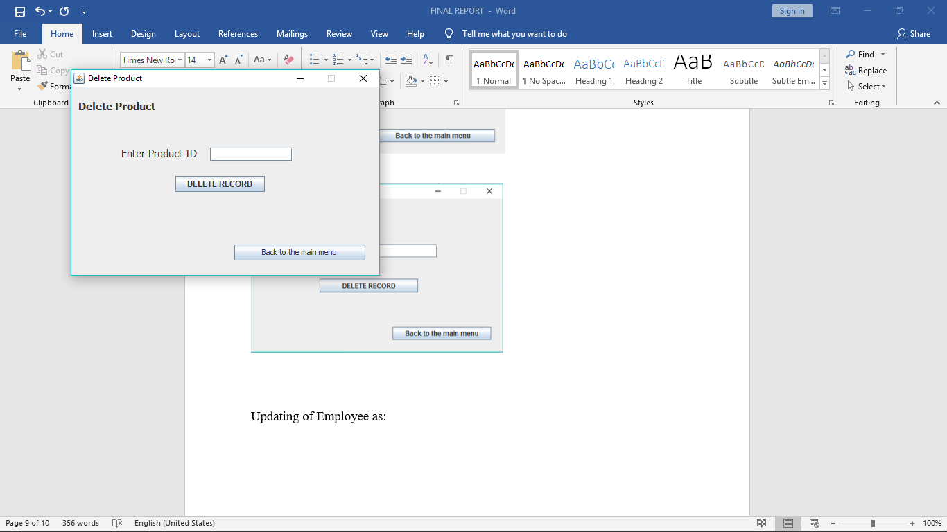

**Updating** of Employee, Supplier, Product as: Tells us how we can update existing records in our database

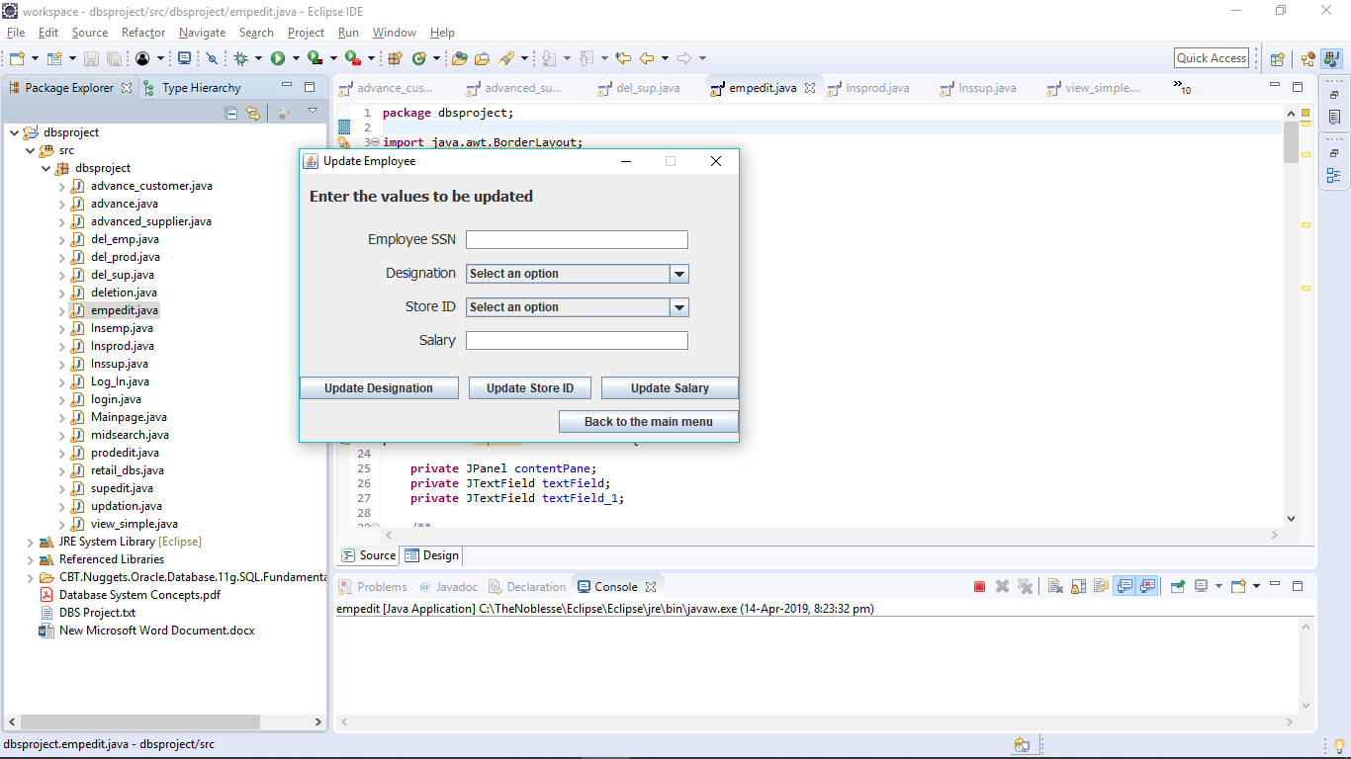

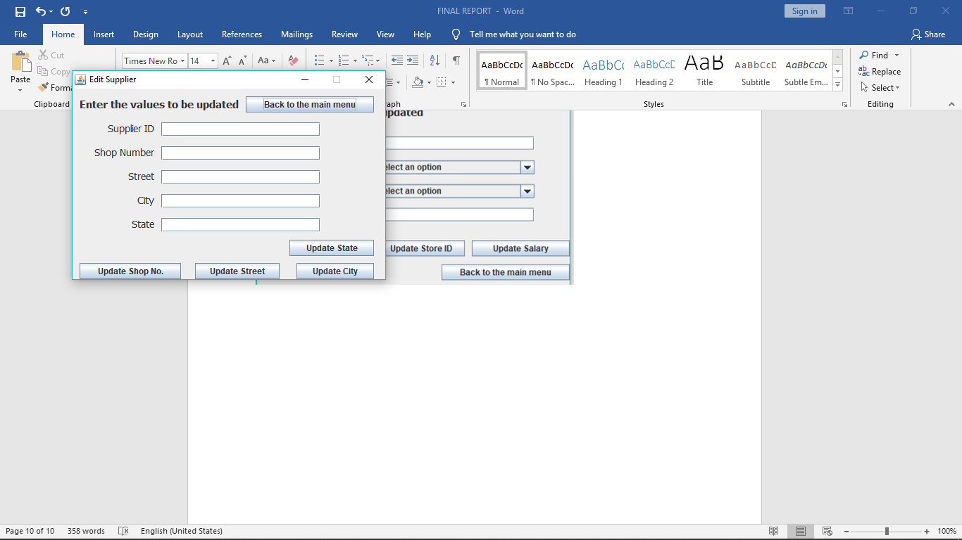

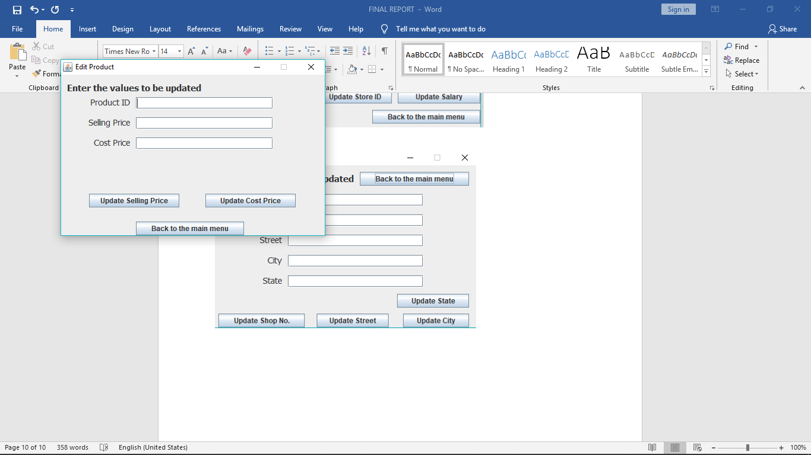

**PSEUDOCODE:**

(Remains same for all)

**try** {

Class.*forName*("oracle.jdbc.driver.OracleDriver");

Connection con=DriverManager.*getConnection*("jdbc:oracle:thin:@localhost:1521:XE", "rahul", "pass");

Statement stmt=con.createStatement();

ResultSet rs=stmt.executeQuery("select ssn from employee where designation='Manager'");

**while**(rs.next()) {

String i=rs.getString(1);

**if** (i.equals(u)) {

flag=1;

**break**;

}

}

**if** (flag==1 && p.equals("root")) {

//this.dispose();

JFrame rd=**new** retail_dbs();

rd.setVisible(**true**);

dispose();

}

**else** {

stat.setText("Invalid credentials,");

stat1.setText("or system error");

stat2.setText("Put SSN (number format) and please try again");

}

con.close();

}

**catch** (Exception ex) {

stat.setText("System error, please try again");

}

**REFERENCES:**

* [www.tutorialspoint.com](http://www.tutorialspoint.com)
* [www.youtube.com](http://www.youtube.com)
* www.docs.oracle.com
* [www.stackoverflow.com](http://www.stackoverflow.com)
* www.eclipse.org